Nicholas Skinner

CS453

Spring 2019

**Project #2 - Point Clouds, Colors, and Range Sliders**

**Final Assignment Images:**

Below are a series of images to display my assignment submission. A colored point cloud with 4 seperate heat locations. I tried to show them all off through the images, as well as displaying the slider effects on the point clouds (name in title, etc…)

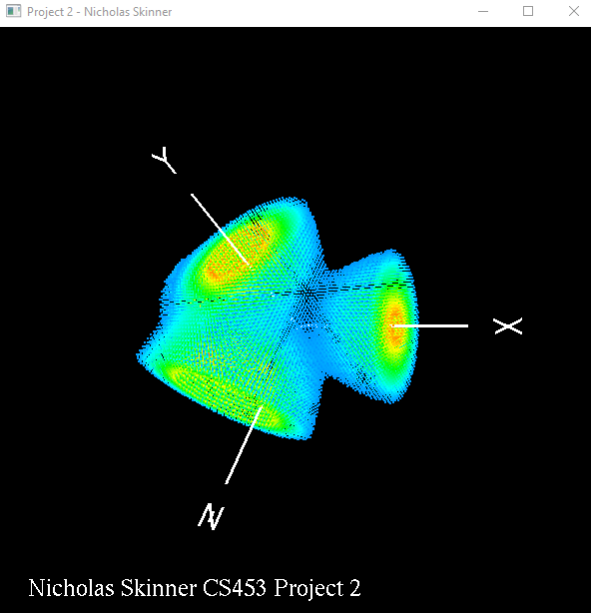

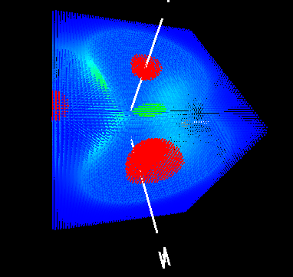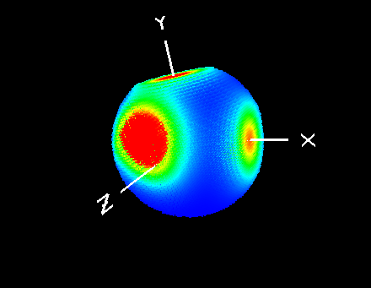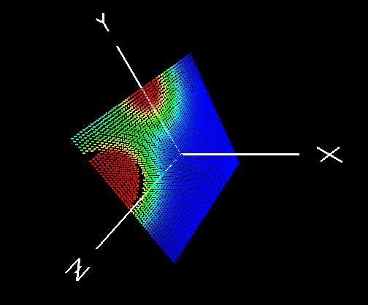

**Review:**

This was a good assignment to start exploring the possibilities of displays for the point clouds, showing slices, a sphere, or even focusing on the locations of heat can create a much more interesting graphic to display.

I ended up paving over my old display( ) code with all the new content the instructor provided, after figuring out how to format it properly, and hook it up to the sliders there was no real issue implementing the other items.

I did encounter a large hurdle though, my Visual Studio 2017 did not support the sliders, and would display NAN when trying to use them, I never found what he cause of this was, but porting the assignment to Visual Studio 2015 seemed to resolve my issues.

Video Here: <https://media.oregonstate.edu/media/t/0_sj85mcr3>